**Problem Statement:**

Create REST APIs that

* Returns a list of all the priority areas from the database
* Accepts the order of priority along with the satisfaction rating for each area for a user and stores it in the database

**Proposed Solution:**

1. Database used in order to store and fetch information is MySQL.
2. Two services are created with following responsibilities:
   1. Area Service – To fetch and store areas for which priority and rating is assigned by user
   2. UserData Service - To fetch and store name of user along with priority and rating for the given area.
3. Following is the structure of tables used to store information:
4. Areas Table:

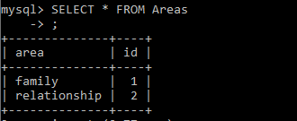

1. UserPriority Table:

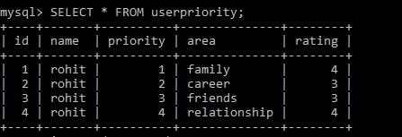

1. Used Postman as a client to make HTTP requests.